**HUMAN COMPUTER INTERACTION**

ELVIS RAI

e

# OVERVIEW

The report evaluates human computer interaction through the application of its principles on the AMAP shopping centre digital sign. The report includes design documents, tested solutions, and their optimisation. It takes in the justification and the evaluation of the above-listed factors.

Contents

OVERVIEW 2

1. Client requirements 3

2. Produce designs for a human–computer interaction solution which meets client requirements (P3). 4

3. Justify the design decisions, explaining how they will meet client requirements (M2). 6

4. Review the designs of a human–computer interaction solution with others to identify and inform refinements (P4). 7

5. Produce a tested human– computer interaction solution to meet client requirements (P5). 11

6. Review the extent to which the human–computer interaction solution meets client requirements (P6). 13

7. Optimise the human– computer interaction solution to meet client requirements (M3). 16

8. Evaluate the design and optimised human– computer interaction solution against the client’s requirements (D2). 19

Recognition vs Recall 19

Gestalt’s law of perception 20

Law of similarity: 20

Law of proximity: 21

Figure/Ground: 22

Law of symmetry: 22

Ergonomics 22

Graphical User Interface: 23

Schneidermann principles 23

Consistency: 23

Informative feedback: 23

Error handling: 24

Reversal of actions: 24

Support internal locus of control: 24

Reduce short-term memory load: 24

Fitt’s law: 24

9. Ethical and legal requirements regarding accessibility requirement 25

Equality Act 27

Copyrights Act 27

Data Protection Act 27

10. Demonstrate individual responsibility, creativity and effective self-management in the design, development, and review of a human–computer interaction solution (D3). 28

How I did it? 28

What went well? 28

What can be done better? 29

References 30

# Client requirements

For this assignment, the client wanted to accelerate and elevate the shopping experience for all customers by developing a digital sign that is interactive and abides by HCI field of study of computer science.

The Director of AMAP shopping centre wanted the digital sign to be accessible to all users regardless of their physical challenges and thus has specified the UI requirements for it. Essentially, he has stated the menus are to be placed in the middle of the screen. The menu will show different categories of stores and services that are facilitated by the shopping centre.

Main menus are categorized as; shopping stores, food, banks, parking, accessible features, exits, and few others. The director has also stated the necessity of the shopping centre’s blueprint or map in the project brief.

The director was also thorough on how the customers should be able to scroll up and down through the categories; zoom in and zoom out the UI and other interactive UI features. As for the audience, I targeted the people from 16 to 50 years old age group in my mind. Young children are not allowed to travel or shop large shopping centres by themselves. In my previous report, we observed that HCI are affected by the type od users. We also studied that expert users are not necessarily young audiences but anybody who acquire technical and computational skills either by education or job requirements.

Regular users are often able to understand and adapt to new UI designs and interact with the machines through pattern recognition or visuals like icons. I also found out that most UI/UX designs are created with young audiences in mind with the idea that they are likely to evolve and escalate the advancement of technology.

As such, it became challenging to design the AMAP shopping centre digital sign for specific age groups only. According to Vogels survey, all people between the ages of 23 and 38, 90% between the ages of 39 and 54, 68% between the ages of 55 and 73, and 40% between the ages of 75 and 91 owned smartphones (Vogels, 2019). Purely based on that survey, I designed the best HCI solution I could possibly come up with.

# Produce designs for a human–computer interaction solution which meets client requirements (P3).

Being a digital sign, the device will be the integration of Menu interface and Graphical User Interface (GUI). Prior to producing an experimental software, I first created mood boards which primarily sets the tone of UI in terms of colour scheme. [The file is attached separately.]

Preferably, I decided to use orange, green, white, grey, and black throughout all user interfaces (UI) of AMAP digital sign. As stated in the presentation, the colour orange will be used for the buttons, so they are easier to locate, green for the validation or affirmation of choice, grey for the background, white for the store lists and black for the texts.

Once the theme was finalised, I then created the flowchart of the digital sign. The flowchart I created fundamentally represents the dataflow and structure of digital sign.

Depending on what customers pick, once they select a certain menu, they will encounter either sub-menu or the store lists. For example, under “Shopping” menu, there are sub-menus like “Fashion,” “Sports,” “Jewellery,” etc. Thus, they are required to pick among those sub-menus for the digital sign to display the store lists. They also have the choice to return in case they selected the wrong menu by accident.

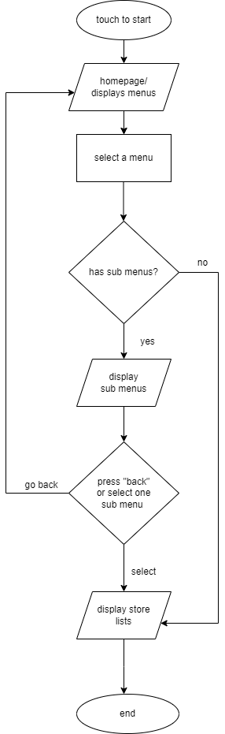

After the completion of flowchart, I moved on to the next step of the design stage which is storyboard. For the storyboard, I started off with the initial draft which was reviewed with the clients. After the review, I made improvements and customized them according to their preferences.

[The final design is attached as a separate PPTX file.]

# Justify the design decisions, explaining how they will meet client requirements (M2).

From the very beginning of this project, my central focus remained on how the Director wanted the digital sign to be interactive. Thus, the selection of theme was crucial.

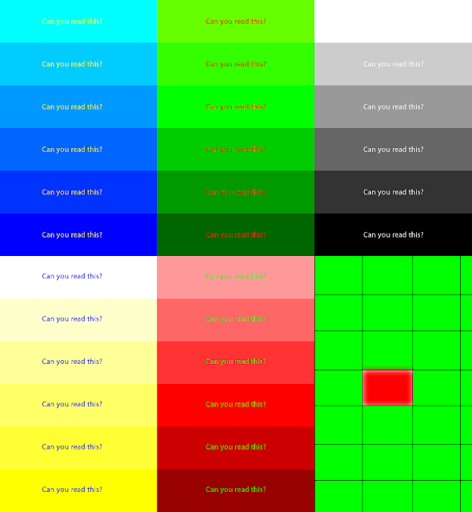

In the picture, you can see that certain colours are not visible in different level of shades. This is one of the HCI principles which falls under colour and luminance.

At first, I aimed for simplicity thus choosing black and white theme for the UI design. However, the Director felt that it was rather plain and common conception instead of “simple”. As he wanted more vibrant colours to personify the moods within the shopping centre, I integrated the colour orange as it was bright, and user would be able to pinpoint them immediately on the screen. Furthermore, white font on the orange background is also clearly visible.

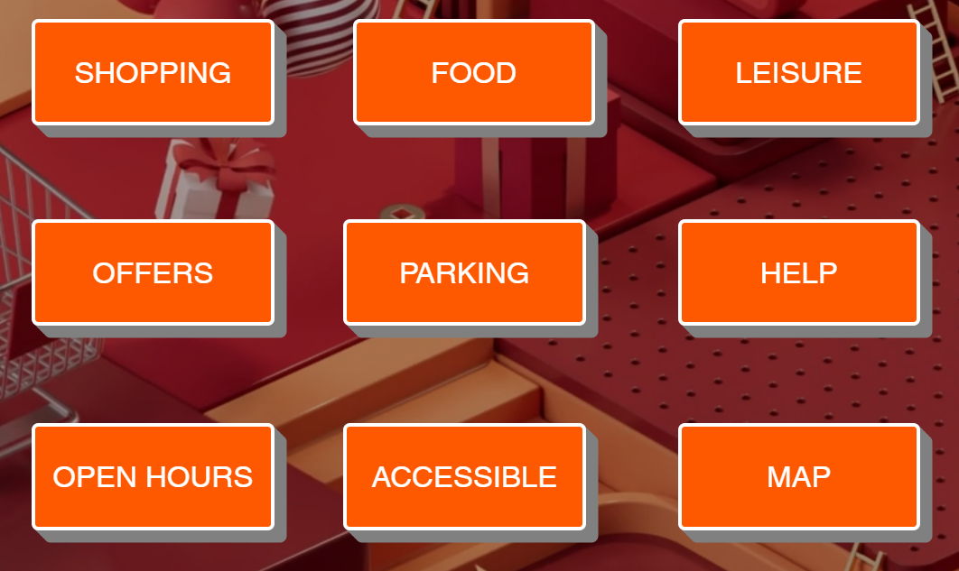

I did not choose yellow because the white font on it would not be visible. The colour red is normally used to indicate signs of danger or warning. I also picked grey for the background because most smartphones user prefer using their devices on dark mode thus their eyes are accustomed to dim lights. White backgrounds are also likely to cause eye strain on the user due to the extreme level of brightness at which these digital signs are set up at.

The final storyboard designs consisted of 9 slides compared to the initial draft with only 5 slides. The increment in number of slides implies the increment in details and depths of analysis I have made when finalising the design for layouts. [The detailed justification of the storyboards is found under notes of each slide.]

In summary, I created more menus at the homepage thus making it easier for user to find the stores they are looking for quickly. I added more menus like “Accessible”, “Services”, “Map” and more.

# Review the designs of a human–computer interaction solution with others to identify and inform refinements (P4).

Once the design documents were completed, I sent them to the clients for review, gathered the feedbacks from them and worked on improvements to be made.

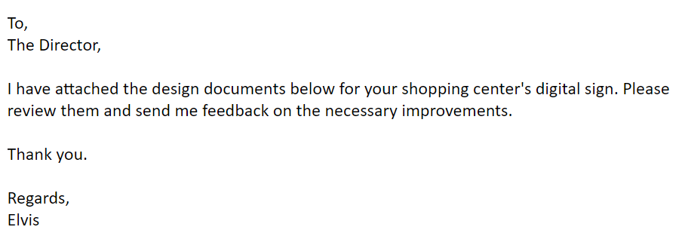

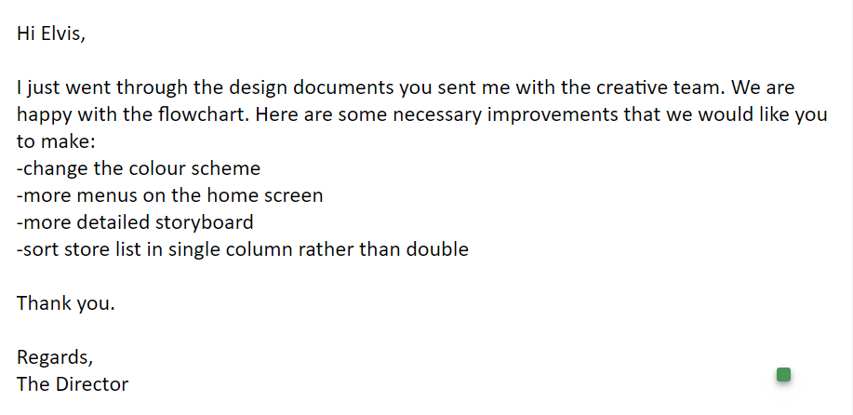

First, they wanted us to change the colour scheme in the mood boards. As mentioned previously, I updated the colour scheme from plain black and white to multiple colour combination.

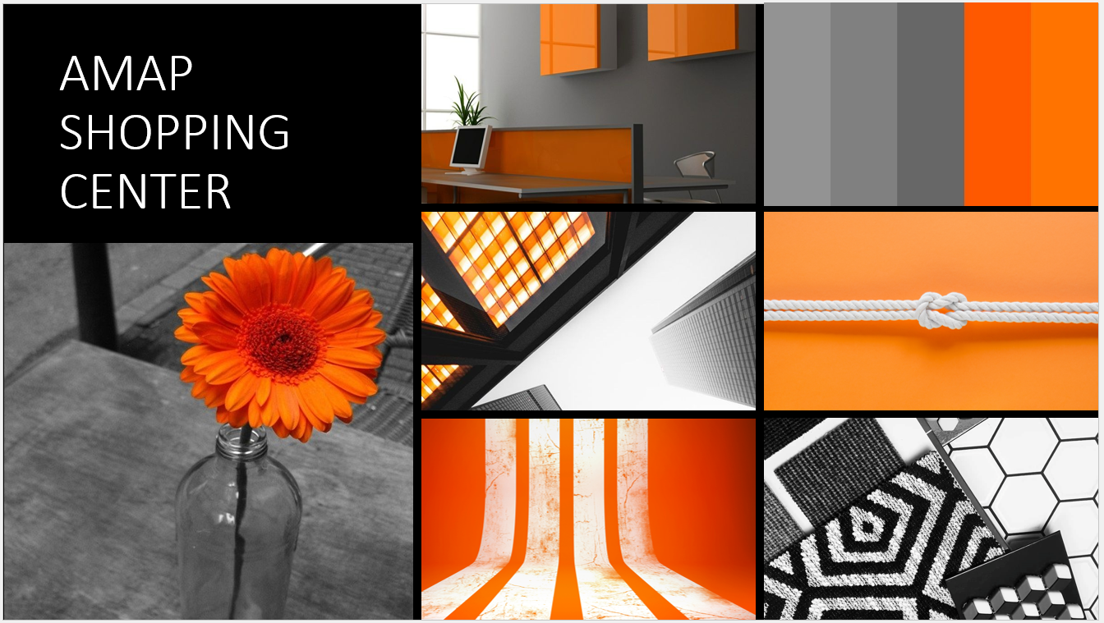

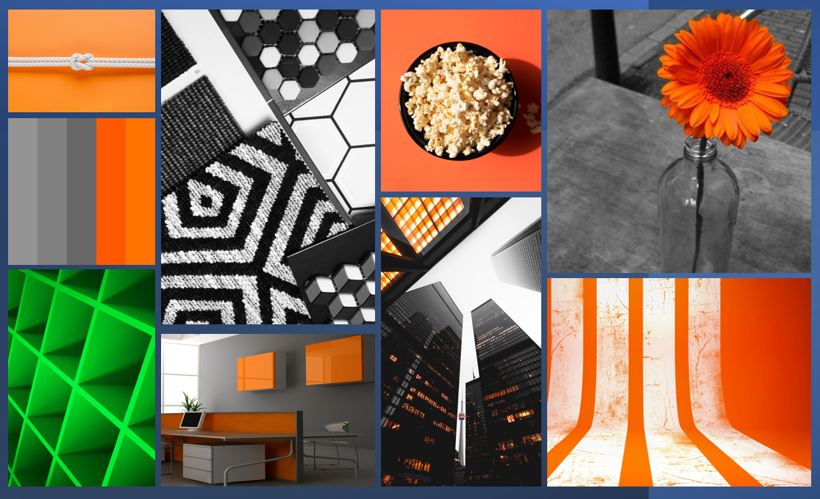

Addition of green colour

As I did not need to make any amends in our flowchart, I kept the original diagrammatical representation. For storyboards, I added more menus as discussed above.

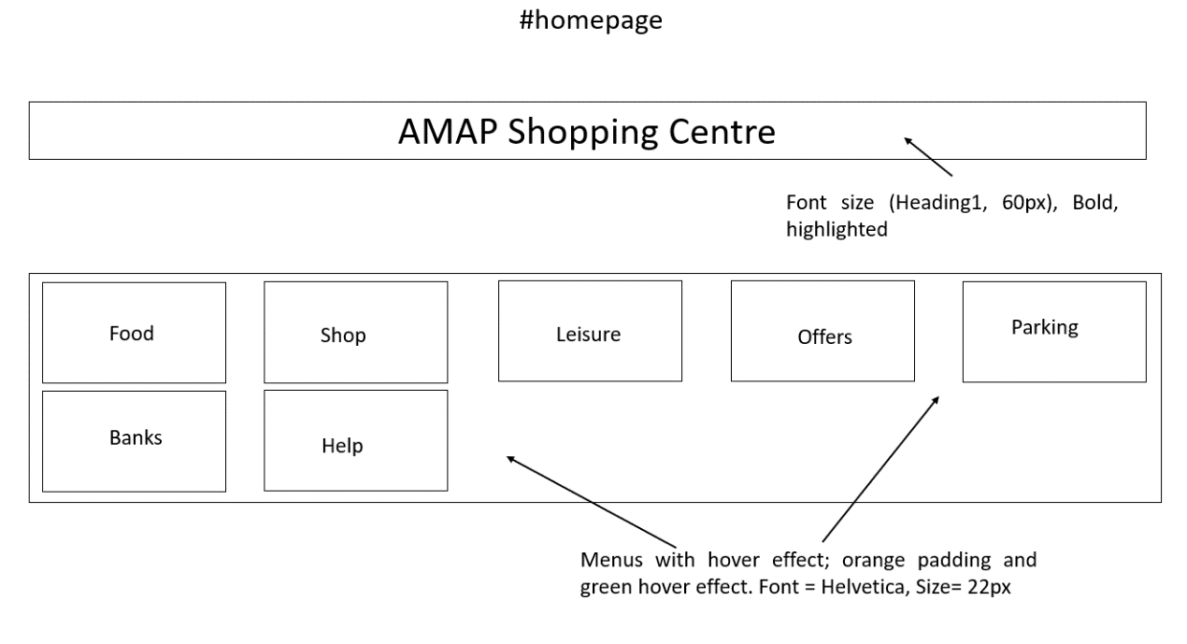

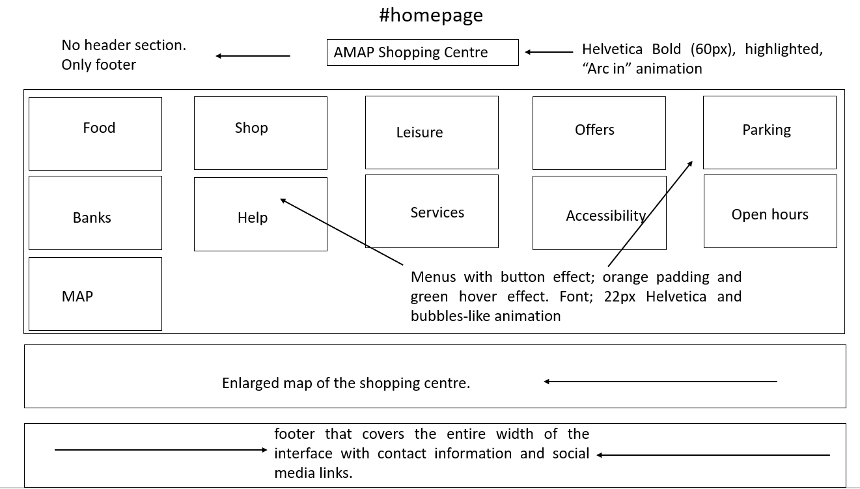

The second screenshot is the final storyboard design created after the review with the clients. Evidently, the slide is more detailed than the previous ones and has more menus. There are three different sections: menus, map, and footer. Moreover, it also has the specific font, size, text formats, hover effects, and animations.

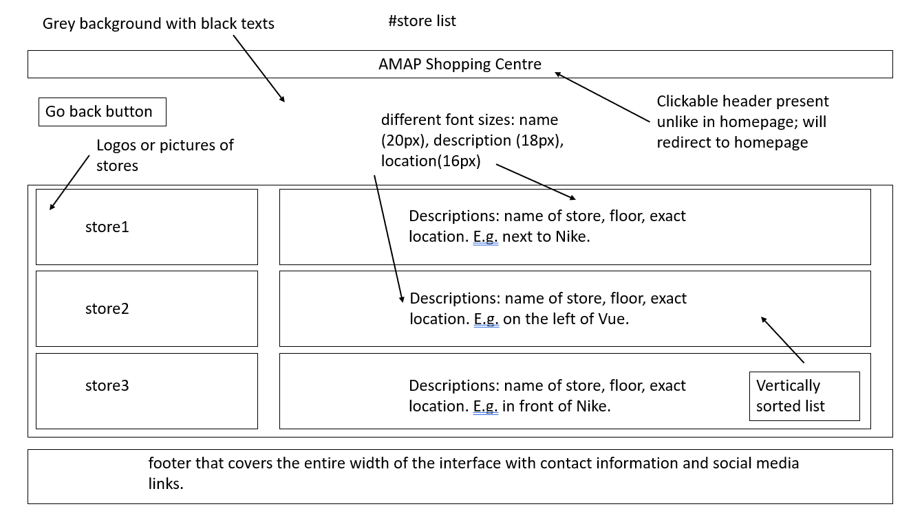

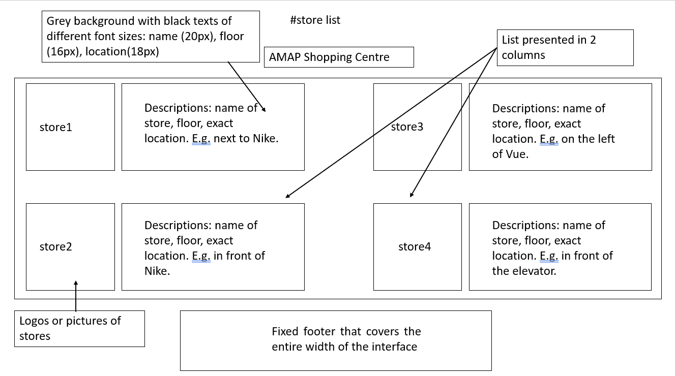

Similarly, there were changes made in terms of sorting layout. Initially, I sorted them in two columns believing that it would be time-effective, so users do not have to scroll for longer period to find the location of store they are looking for.

However, the Director wanted them in single column as I believed that having single columns will make sorting easier. For example, if the store list were sorted in alphabetical order, the two columns would be confusing for some people because it is possible that their eyes miss the stores listed on the right-hand side of the screen while scrolling rapidly.

# Produce a tested human– computer interaction solution to meet client requirements (P5).

For the actual software I created three layouts design for menus and the homepage. In the initial solution, I had plain background instead of graphics with smaller menu.

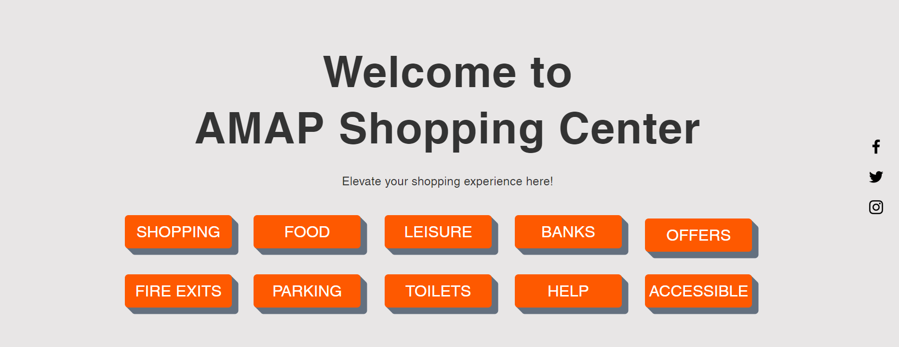

According to the director, the colour grey at the background was great choice for eye comfort and making the menus stand out. Unfortunately, it was too “ordinary and undecorated”.

So, I increased the size of in consideration of customers with poor vision and added 3D animation.

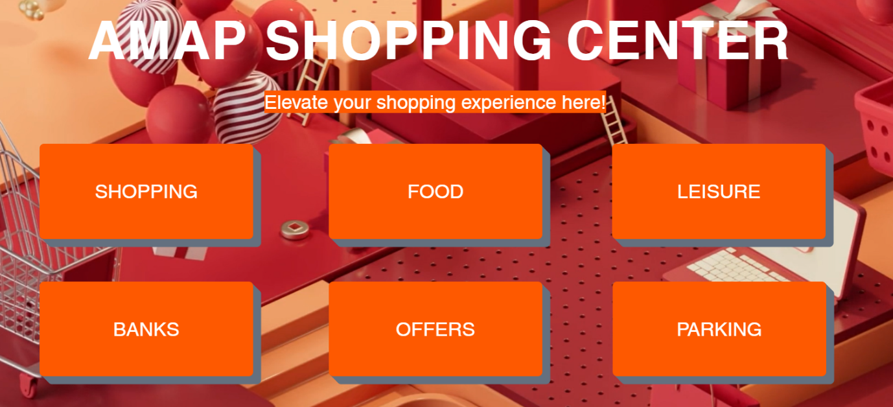

However, it occupied a lot of interfaces and made increased the vertical section of the screen. Furthermore, it also contradicted with one of the HCI principles which is Fitt’s law. This law fundamentally measures the time taken by the user to find the target in UI. In relation to the law, larger menu means that users will have to scroll down every time they go back to the homepage in circumstances where they want to look up location of multiple stores.

The second design rejected the notion of large sized menus and made it colourful to make all menus look different.

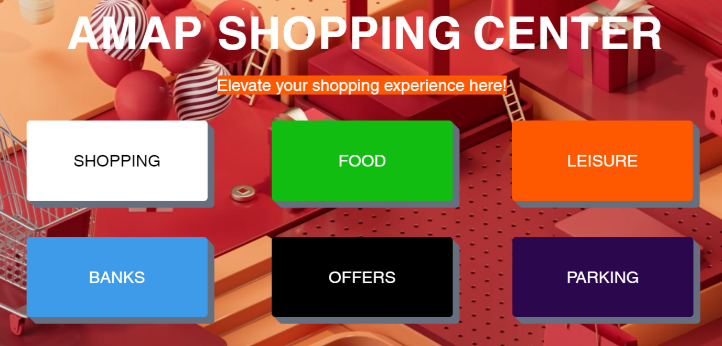

While it sounds somewhat a better plan than the first one, the problem presented itself as theme inconsistency. In the picture, the colours used did not create a rhythm with the colour of the background. What’s more, the background is 3D loop animation rather than still image. This makes it difficult to focus on a single area.

The other purpose of this plan was to give the clients options of what colour they would like to pick despite having stated that I would be using orange colour.

As predicted, the clients wanted me to follow the final storyboard and design the software accordingly. As a result, this is how the menu buttons appeared.

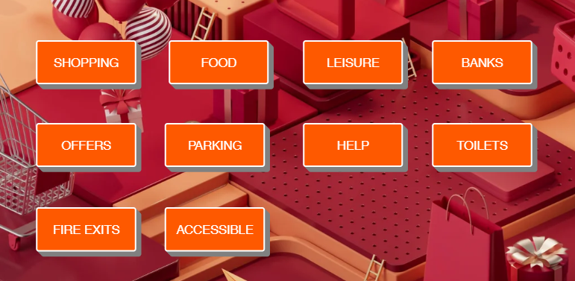

Regarding the layout of the store, I sent the pictures of how the dual column would look like compared to their preferred single column. The clients were consistent with their decision which made me proceed with their decision without having to worry about the sudden change of heart near the deadline.

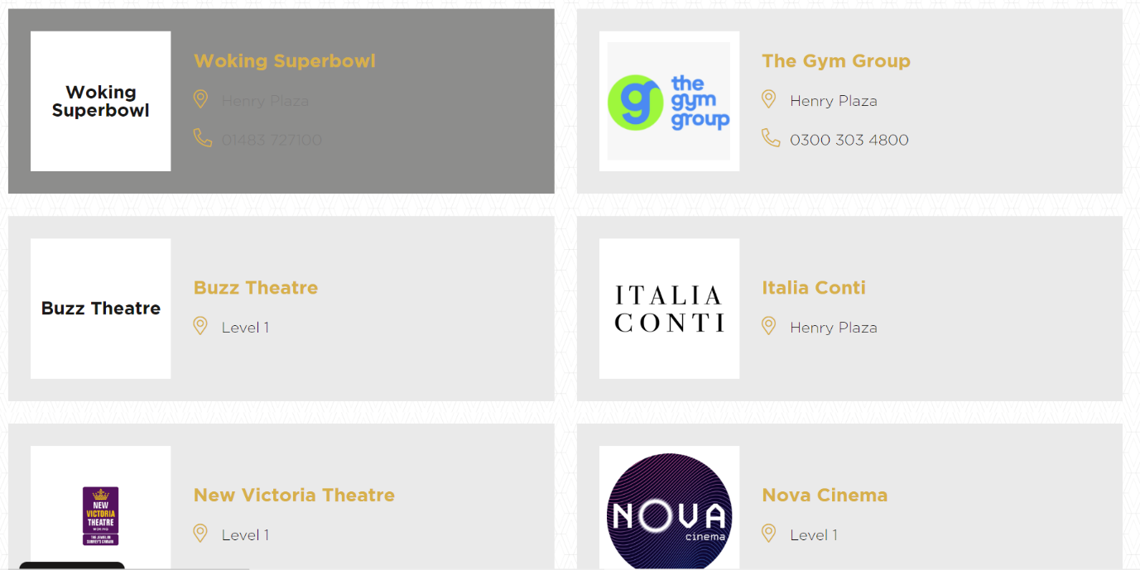

# Review the extent to which the human–computer interaction solution meets client requirements (P6).

The HCI solution I created was not perfect on a single attempt. Before I conclude the project, I decided to test it and review them with the clients. During the test, I created a table consisting of data on the type of outcome I had expected and the actual outcome I got. The test would also inform me about the behaviour of the system.

|  |  |  |  |  |  |
| --- | --- | --- | --- | --- | --- |
| Test | Interface | Test area | Outcome  expected | End-result | Comments |
| 1. | Homepage | Animation | -arc in effect  -accurate time delays in animation | -menus appeared faster than the welcome texts | -fix time delays |
| Menus | -hover effect working  -bubbles like animation  -time delays in order | -speed of bubble animation too fast | -change speed of animation  -fix time delays |
| Social media links | -redirects to application respective social media page  -position | -overlapped with other contents | -fix errors |
| Hover effect | -changes color upon hover | SUCCESSFULLY ACHIEVED | N/A |
| 2. | Sub-menu | Buttons | - redirects to correct store lists | SUCCESSFULLY ACHIEVED | N/A |
| Logo | -redirects back to homepage | SUCCESSFULLY ACHIEVED | N/A |
| Hover effect | -changes color upon hover | SUCCESSFULLY ACHIEVED | N/A |
| 3. | Links | All pages | -redirects to accurate pages | SUCCESSFULLY ACHIEVED | N/A |
| 4. | Texts | Alignment,  Grammer | -aligned as designed  -no grammatical or spelling errors | SUCCESSFULLY ACHIEVED | N/A |
| 6. | Images | Alignment,  Size | -aligned horizontally or zigzag according to pages  -visible sizes | SUCCESSFULLY ACHIEVED | N/A |
| 7. | Store lists | Alignment,  Layout | -aligned in single column  -same layout on all pages  -accurate location of stores | -error on location | -rectify errors |

The first error on the solution was the time delays on the animated objects in the UI/UX design. In detail, the menus appeared faster on the screen instead of “Welcome to AMAP Shopping Centre” text. As it was a simple error, very short period was spent on the correction. I set the time delay to zero for the text and the menus at 0.8 seconds.

The second error was related to the speed of animation on the menus. I chose “bounce in” effect which means they would recoil or bounce once it appeared. However, the animation power was set to be “hard”. This makes the animation too fast for the eye to capture. So, I customized it to “medium” to make it seem smoother.

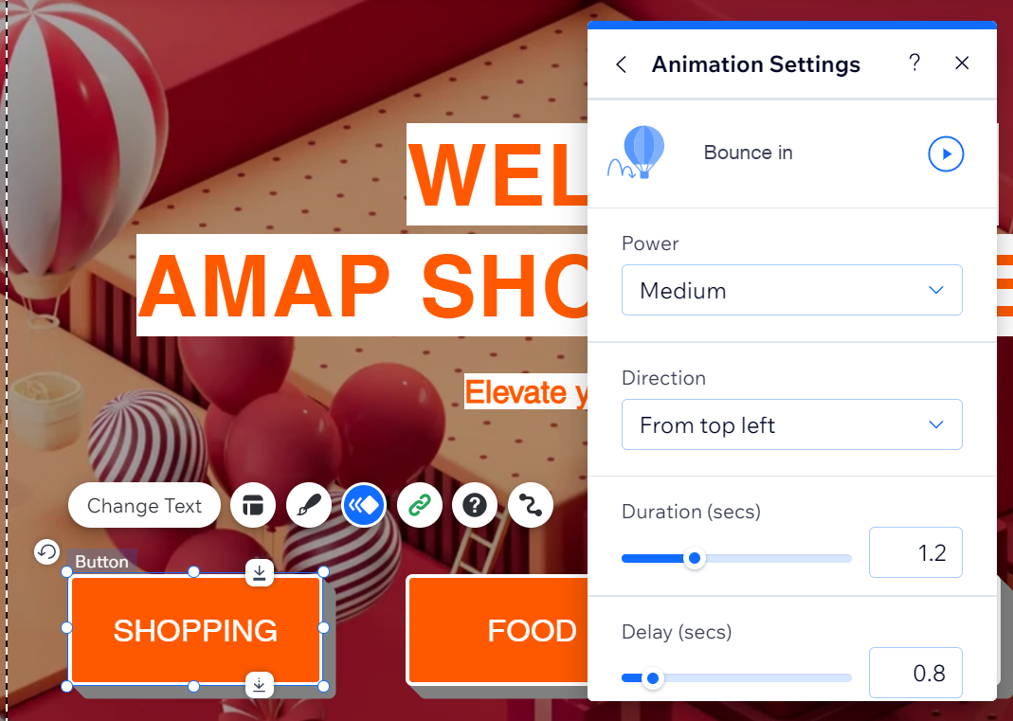

Social media links also did not work as intended. Instead of redirecting users to the correct social media, they would misdirect them to other social media accounts. For example, clicking the twitter sign opened the Instagram and vice-versa. This issue was also fixed by inserting accurate links to respective icons.

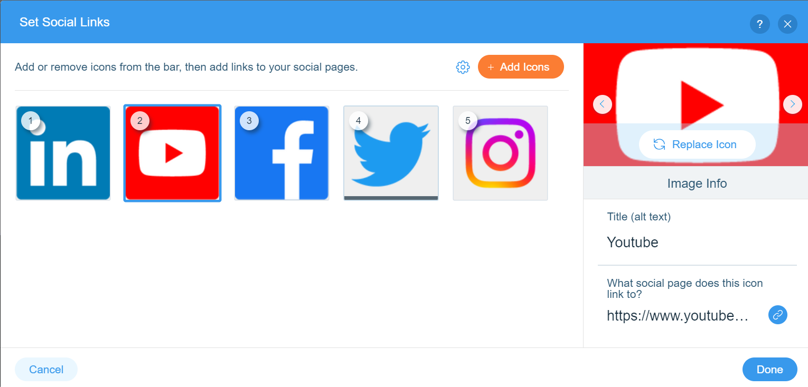

Lastly, a major flaw was found on one of the pages where the location of two different store were listed as the same namely, Stussy and Supreme.

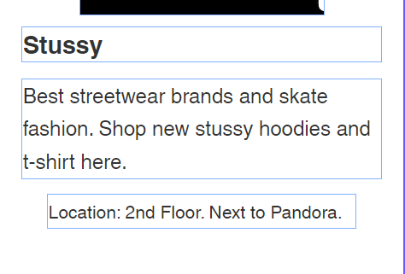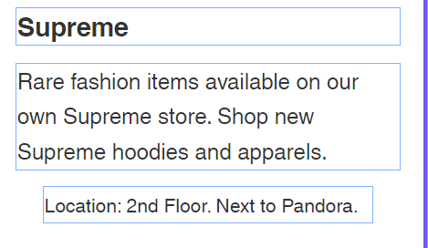

**Error: Same location**

The issue was also solved without any challenges.

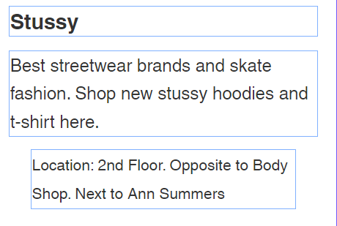

**Error fixed**

# Optimise the human– computer interaction solution to meet client requirements (M3).

Rather than customizing the HCI solution according to the client’s needs, my biggest challenge was its optimization. Firstly, I made sure that there were no grammatical or spelling errors. This was also examined during the reviewing stage of the HCI solution such as the location errors.

Secondly, it is extremely important that the digital sign solution is navigational. For instance, I designed the header to be clickable so that users could return to the main directly rather than going back one page after another. Other navigable links were also added.

1. Map button on the menu would take users to the map section of the same page without them scrolling down.
2. There is a “Click here” links at “Parking” page which will redirect users to the opening hours of the shopping centre.
3. An underlined text in “Services” section navigates user to information about accessible facilities like toilets and lifts.
4. The “Go back” button also serves similar function as the logo.

[Unoptimized]

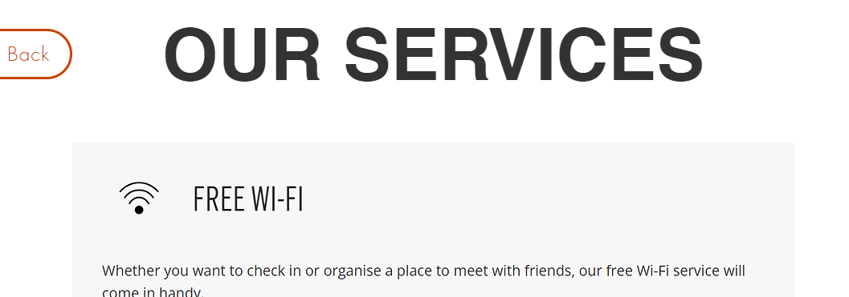

[Optimized]

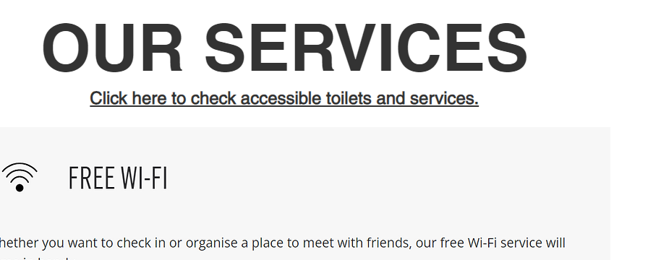

In similar way, I also optimized the logo of the social media icons. Originally, there were two sets of social media icons that overlapped one another.

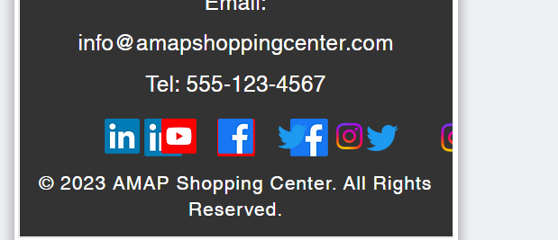

This was extremely challenging to fix as the origin of the issue could not be traced quickly. I had mistakenly added two sets of social media icons while attempting to change its layout from vertical to horizontal. Through multiple attempts, I successfully rectified this error.

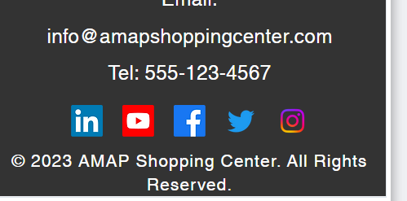

Additionally, I changed the hover effect from grey to green as per the mood boards and storyboards.

|  |  |
| --- | --- |
| before | after |
|  |  |

Ultimately, I also optimised the SEO of the digital sign by using including metatags and keywords. I added this feature in case the clients wanted to convert the same feature into a website. Doing this, would not only give them exposure in search engines like Google but also increase the traffic in their website.

To optimise the SEO, I had to select each logo and add alternative texts on it. I also used a SEO tool which provides me the summary of areas, sections, pages, images, and links that needs optimizing. It can be seen in the second picture that I added descriptions about the site to increase its visibility in search engines.

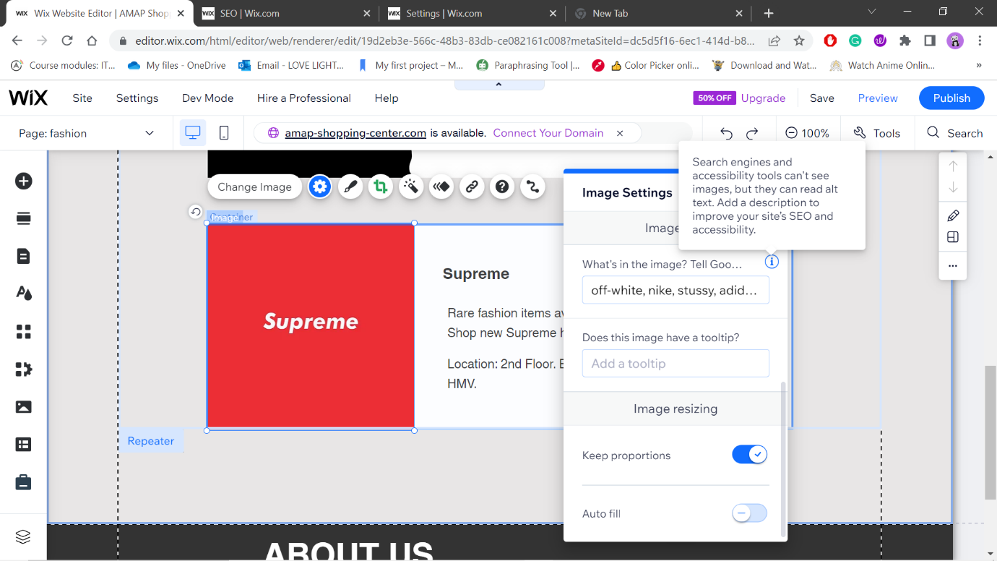

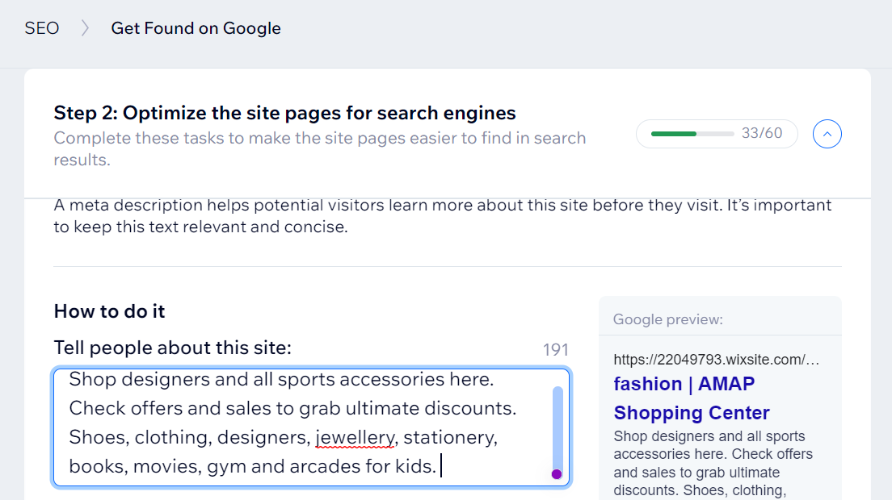

# Evaluate the design and optimised human– computer interaction solution against the client’s requirements (D2).

## Recognition vs Recall

In my previous report, I broke down the difference between recognition (being able to recognize something) and recall (being able to remember something). This is one of the principles of HCI.

To make sure that my HCI solution is easy to recognizable, I used subtle animations on the background image. The buttons and the texts in homepage are also animated with different styles. This will trigger events that user has previously interacted when visiting AMAP shopping centre. As the users are not required to create accounts, enter bank details, passwords, and other credentials, this HCI solution will reduce memory load, hence, making the system usability easier to recall.

Nonetheless, there is also a video on the “help” menu which contains the tutorial on how to use the digital sign. Our theme consistency is another part of HCI principles that will help users recall how to navigate the system as we have only used limited set of colours throughout the UI.

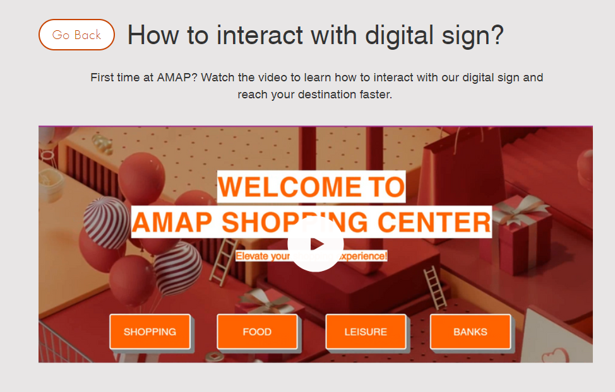

## Gestalt’s law of perception

Gestalt’s law of perception which studies how one interprets information and makes uses of it is also applied on the digital solution.

### Law of similarity:

First and foremost is the law of similarity. I have applied exactly similar layouts for all categories of store lists and all of them covers equal area of the interface. The stores are listed in rectangular boxes with the name on top; description in the middle; and location at the bottom. The icons used for toilet sign and fire exits and the icons that are placed in the AMAP shopping centre are also alike. Visitors will not find a different design on the actual shopping centre in contrast to what is found in the digital sign when they are walking through the halls.

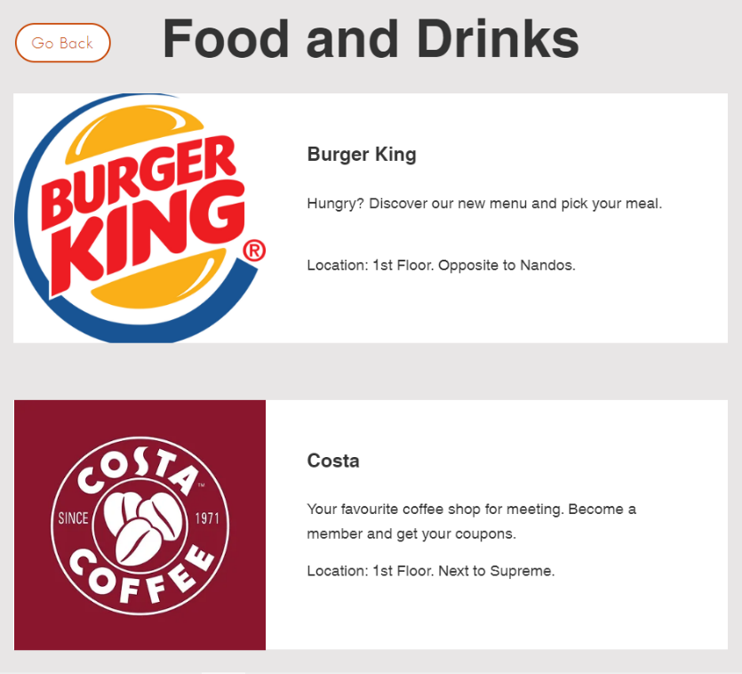

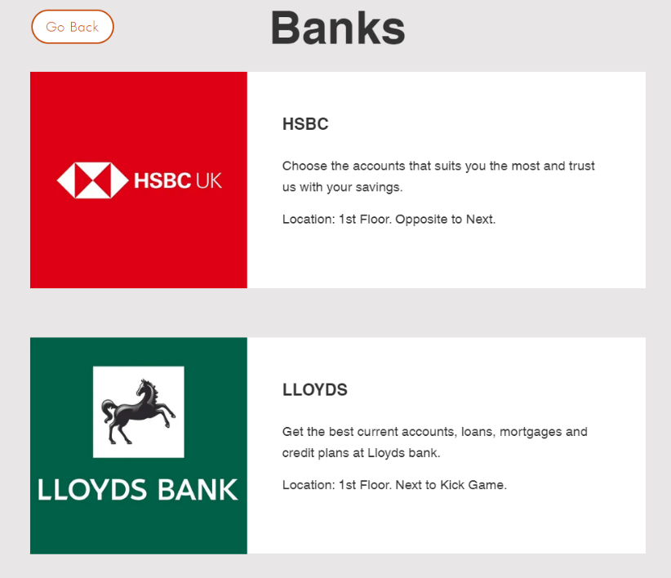

### Law of proximity:

Law of proximity groups a set of elements together that fall under the same category and can be viewed as single entity. Instead of listing all the store list under a single menu, I created sub-categories and grouped them together by their attributes. All the shops related to clothing are sorted under “fashion”, accessories for athletes under “sports” and so on.

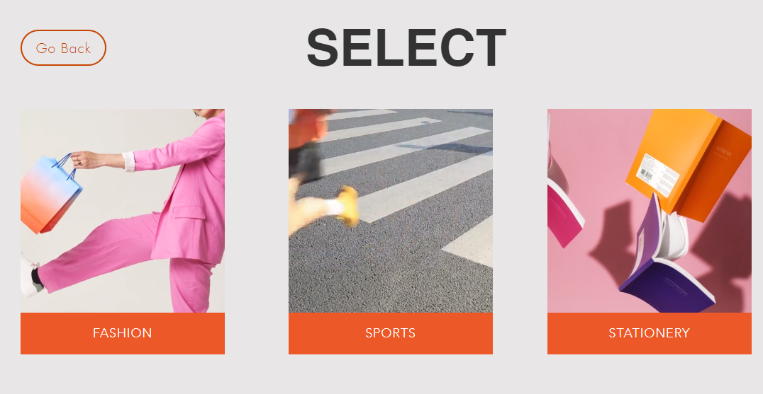

### Figure/Ground:

Regarding figure/ground, which shows our ability to distinguish foreground and background, I highlighted the headings in the homepage. The white font on top of orange padding is also readable. The font “Helvetica” and the large font size adds more to this law by making each character clear and separable from the background.

### Law of symmetry:

Finally, the law of symmetry can be found on the shape of menus which are all the same and the return button that are placed on the left corner of the interface that are cylindrical in shape in all pages.

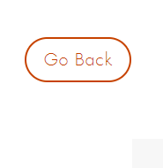

## Ergonomics

Ergonomics is another field of study in HCI. To reduce the eye strain or prevent the users from squinting their eyes due to extreme brightness, I chose grey (hex: #E8E6E6) colours for all whitespaces. In the above table of contents, I attached a colour gradings and font on top of it proving that some colours to not work together to provide comfort for its users. This shows the significance of selecting the right font size and colour to advance the machine’s usability.

The drawbacks depend upon the location of hardware installation. For example, installing digital sign in the middle of pathway is extremely hindering and can result in overcrowding specific zones; too small hardware can be hard to locate and too large can consume greater spaces. Other factors to be considered are the size of the interface, hardware design (cannot be spiky), distinguishable design, height of the display and friendly appearance.

## Graphical User Interface:

Being GUI, the digital sign utilizes pictures, animations, icons, etc. GUI is highly interactive by nature compared to Command-Line Interface (CLI). This also boosts users’ ability to memorize contents and establish familiarity with the system.

However, the design requires more storage and processing power. GUI also consumes more electrical power. Maintenance is hard and expensive to upgrade graphic cards. The operating system on which it runs is also a factor to be considered.

Being a menu-based interface, it critically important to understand that bad designs and numerous options can either be confusing or overwhelming. Having only texts also makes UI less engaging.

## Schneidermann principles

Consistency:

Throughout this report I have repeatedly talked about the importance of theme consistency. The idea of consistency can be found everywhere in the design such as colour, layout, contents and so forth. The prepared digital solution is also consistent in its behaviour and performances such as the quality of animation and transition between pages.

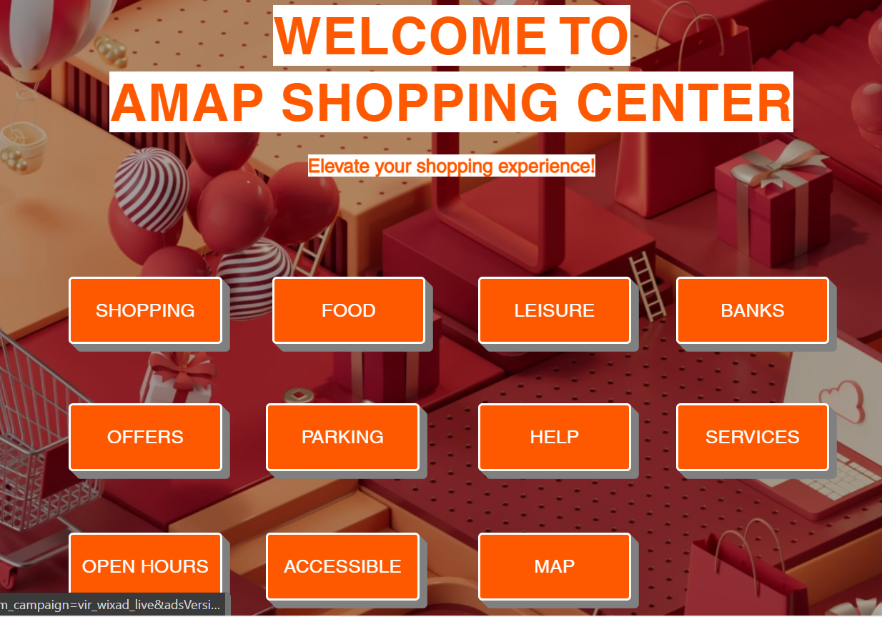

Informative feedback:

In some pages there are instructions, for instance, “select”, “go back” or “click here”. These instructions prevail to let users know their next course of action in case they are stuck in the middle of their activity.

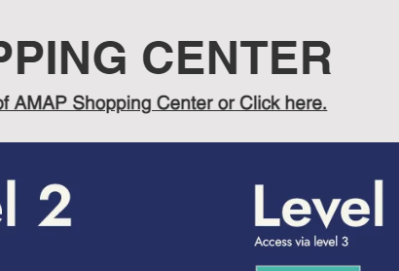

### Error handling:

Users can perform any actions without being worried about the result of their actions like pressing the wrong button because the digital sign is designed in a way that there are no triggers or alarms in case they choose “food” instead of “map”. Whatever buttons are pressed, or links are clicked, the digital sign will only show the content it has which is either store list or information on a particular topic.

### Reversal of actions:

This principle emphasizes on the user’s ability to reverse their action in case they change their mind or in the events of accidental clicks. In my design, I have included buttons to go one step back or directly to homepage. The digital sign accepts fingertip movements and taps as an input deeming the reversal of action not as necessary as other principles.

### Support internal locus of control:

I have also incorporated the design for the system so that it displays results only upon user’s actions. There are no forms of AI that will suggest something to the user automatically or by predicting their next activity by calculating previously gathered data and forming user patterns. This is because, according to Schneidermann’s principal, humans should always be in control of the system, not vice-versa.

### Reduce short-term memory load:

This principle refers to the recall aspect of HCI principles. Due to fixed number of menus, the number of operations it can perform are also limited. The menus are listed according to priorities like 1) shop 2) food 3) leisure and so on.

Fitt’s law:

We introduced this concept in the early contents of this report. In brief, this law determines the usability and productivity of system based on how quickly the users are able to select what they are looking from within the interface. To ensure that users are not queuing in front of the digital sign to locate a store, the design must be simple and easy to use. This could be the size at which the texts are displayed; the choice of logos for the stores; sorting manner etc.

The smallest font-size in my design is 15px; the menus have 22px font-sizes and heading 1 is 60px. More importantly, the interface can also be zoomed in and zoomed out which is another complimentary accessible features.

[Zoom in]



[Zoom out]

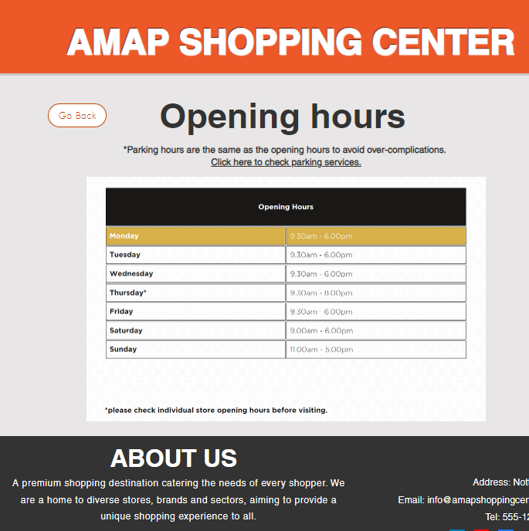

# Ethical and legal requirements regarding accessibility requirement

The digital sign solution carefully considers the ethical and legal aspect and welcomes all customers. On the subject of ethical standards, there are no prejudice against people of different backgrounds, race, gender, or any forms of disability.

As AMAP shopping centre was totally accessible to the disabled customers, I had to represent their ethical standards in the HCI solution as well. That is why, the Director wanted the accessibility options to be present in the main menu. Doing this will also allow the visitors to interpret that the shopping centre is user friendly for all. The accessibility services also help them experience the enhanced level of excitement and fun as other people.

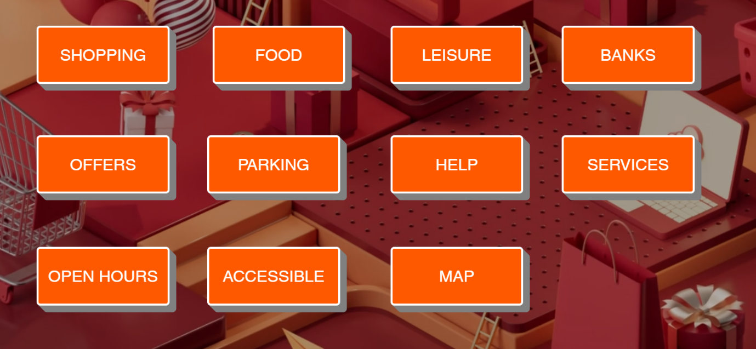

Under the accessible facilities, AMAP shopping centre offers:

1. Disabled parking
2. Accessible lifts
3. Accessible toilets
4. Braille on lifts
5. Shop assistance for visual impairment
6. Zoom in/ Zoom out

In the HCI solution, to access information about disabled parking, users can simply select “Parking” and it will show them all the necessary information on that matter.

For the rest of the accessibility services, users can select “Accessible” and find information on the next page. One of the most efficient human-computer interaction here is the reduced number of times that users have to select options from the menu. On a single click, the information is simply displayed. Not to mention, the contents are also laid out in clear and readable format and size.

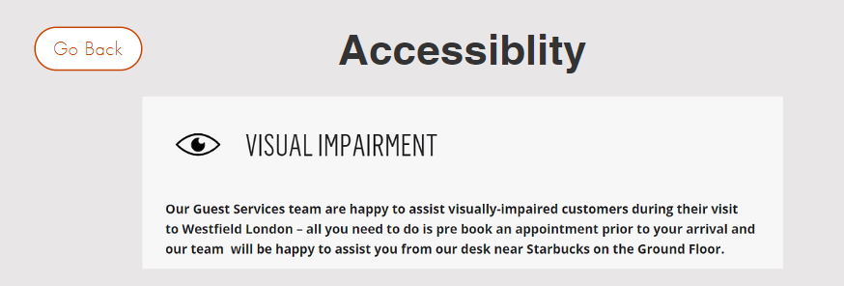

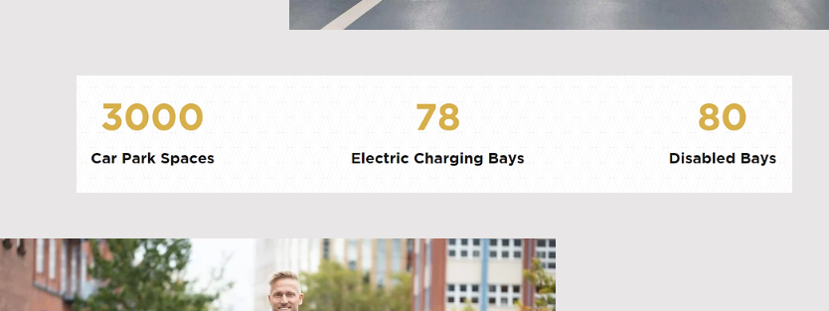

## Equality Act

Following these ethical standards and rules are a part of legal obligation. According to the Equality Act 2010, all human beings are protected by the law should they be discriminated against because of their disabilities. This law secures their rights and protect them from any kinds of prejudice.

For example, if I were to show any signs of hostility towards them or discriminatory behaviour by giving them less priority or not making my digital sign inclusive to all, I am punishable by the law. The law does not tolerate neither direct nor indirect discrimination. Thus, me excluding accessible services from the digital sign implies that I show signs of offence towards them. Consequently, I will be punishable by fine up to 5,000 pounds (Government Equalities Office, 2022).

## Copyrights Act

Concerning the business itself, I have ensured to ask for permissions to use any pictures, logos, or other graphic content that belong to the original creator or the person in the picture working for the AMAP shopping centre. Failure to abide by the Copyrights Act 1988 can be prosecuted as criminal offence and the charged is punishable by fines or imprisonment depending upon the severity and the scale of the damages.

The copyright law also prevents other rival companies to steal my designs and use it as their own. This will ensure the uniqueness of my digital sign solution and band the perpetrators from copying or creating anything that resembles it.

## Data Protection Act

Another legal requirement that my HCI solution complies is the Data Protection Act. This is because, no users are required to enter their personal information to access the digital sign. The software is designed to launch with a single touch without any other data input such as emails and passwords. Such feature will ensure that customers’ data are not entered in public hardware will is used by hundreds of people daily.

# Demonstrate individual responsibility, creativity and effective self-management in the design, development, and review of a human–computer interaction solution (D3).

## How I did it?

For this project, I invested most of my time planning on design documents before the actual HCI solution. I preferred to approach in that order to avoid returning to the HCI design and making constant changes accustomed to the storyboard.

Beforehand, I decided on the data flow of the digital sign, therefore, compelling myself to create a flowchart. The early design of flowchart had lots of contents that represented data flow for all eleven menus. So, I established a pattern among them and made a single flowchart that demonstrates the flow of data for all buttons in the solution.

The mood boards were inspired by one of the Schneidermann’s principles: Figure/Ground. I wanted to make the menus stand out, so I used bright colours. However, I had to be cautious on what colour would create harmony with bright colours. As seen in the report, I initially picked light grey, but it received negative reviews. Then, I customised it and added similar themed animation. This would make homepage attractive whilst reflecting original colour scheme.

I created detailed slides representing all pages and user interfaces on MS PowerPoint. I created 2 sets of storyboards: the first had fewer slides as its purpose was to serve as the foundation for my final design.

As per the instruction, I also used Wix to create the HCI solution. This saved me a lot of time to experiment a lot of features, templates, settings, and more until I finally decided how I wanted my digital sign solution to look like.

Completing all the above documents, I asked for reviews on them. I sent the links to my friends and even demonstrated the unfinished version to my instructor. It received generally positive feedback. One friend said it took time to load the data on his phone, thus, implying that the graphics and animation used on the design requires more powerful devices.

Improvements were made and the designs were customized to meet the client’s preferences once all the feedbacks were successfully gathered.

## What went well?

Compared to my previous projects like website development for unit 15.2, I remembered to take screenshots of the errors I made as I developed the HCI solution. That helped me to make notes on the areas of improvements I need to make and to list of features and mistakes I improved on the report.

The animation on the homepage and the transition on the pages are my biggest accomplishments on this design. The 3d animation which continuously loops in the background is also related to “shopping” theme. There are bags and balloons in the image. This will not only make the digital sign presentable but also synergize the atmosphere with the shopping centre.

When it comes to transitions, the new pages slide in from the right instead of slowly revealing itself. This transition makes the customers feels like they are watching a simple PowerPoint presentation rather using a complicated website.

I also referred to three different shopping centre websites: Westfield shopping centre, Victoria centre in Nottingham and Victoria palace shopping centre in Woking. These websites gave insights on how the design should continuously radiate the vibrant shopping energy, for instances, use of images that are relevant to entertainment, movies, food, luxuries, clothes etc.

I kept the design simple following the Law of Similarity (Gestalt’s law of perception) which allowed me to conveniently copy the layouts for multiple pages like shop, food, leisure, and banks. I also believe that the format in which I have published the information is very readable and easily understandable. I used fewer texts and more graphics to make the HCI solution interactive.

## What can be done better?

With more time, I believe I can add more pages with more navigable links and buttons. I also wanted to include several more features on the design like speech to text which is extremely rare on digital sign. Most digital signs play audios and videos while displaying advertisements. However, as an input, it only has search buttons where users can type in certain keywords to look up stores and information.

These digital signs may or may not have text-to-speech features on them but being able to add both speech-to-text and text-to-speech, features would be my biggest achievements.

I also believe that the addition of search button would have increased the efficiency of my HCI design tremendously. Due to limited number of stores, I was able to include on this project, I believed that the search button would not be as necessary. Nevertheless, search button is always efficient at all situations which I learned afterwards.

I have included 20-30 stores of different categories including banks. I would love to increase that numbers and make it feel real. The increment in the number of stores invites another important feature that is common in all digital signs which is sorting methods.

In my design, I have sorted them alphabetically. But the addition of other sorting methods like based on popularity, most visited, specific type of accessories and more would truly elevate the interaction with digital sign.

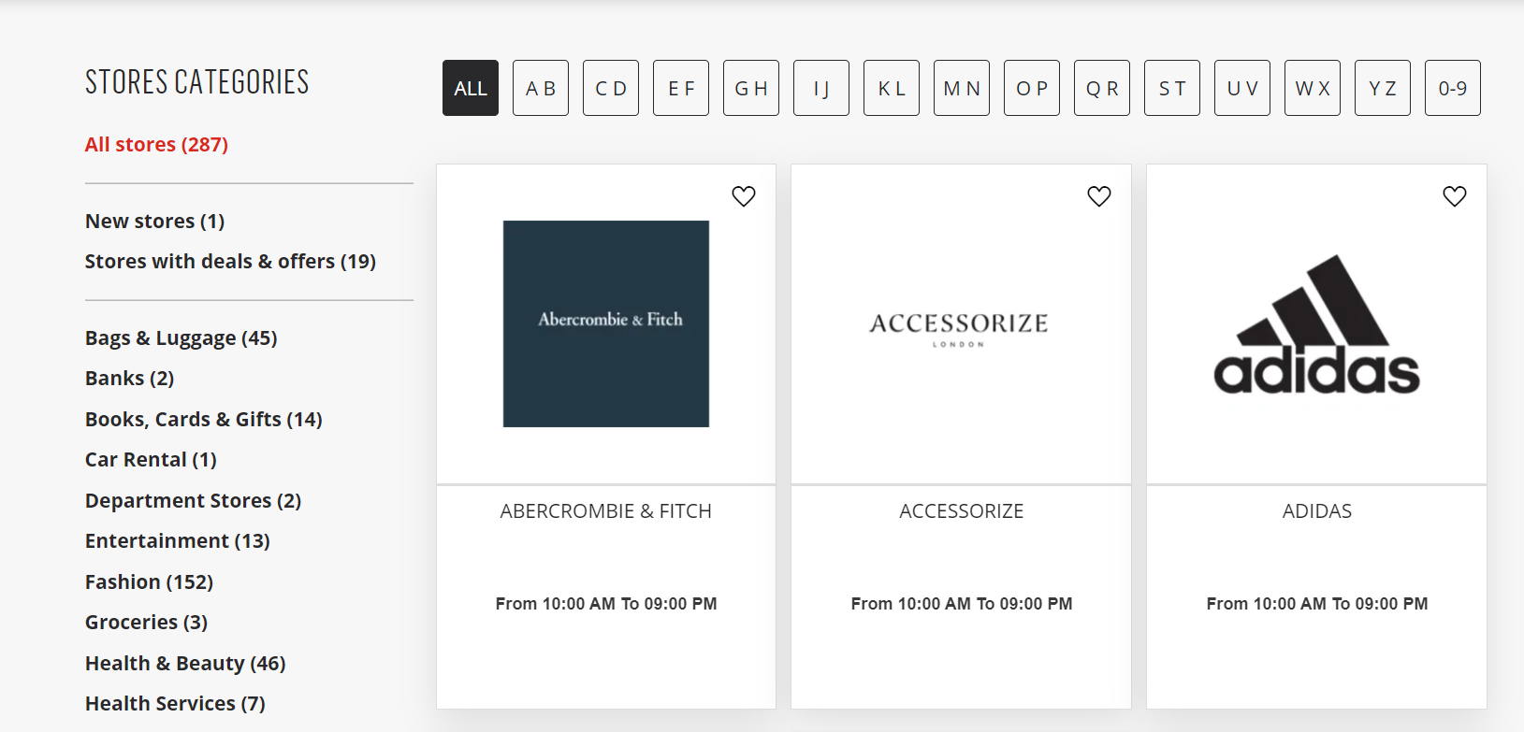

# References

Government Equalities Office (2022). *Equality Act 2010 - Explanatory Notes*. [online] Legislation.gov.uk. Available at: https://www.legislation.gov.uk/ukpga/2010/15/notes/division/3/8#:~:text=369.It%20makes%20it%20an [Accessed 8 Jul. 2023].

Vogels, E. (2019). *Millennials Stand out for Their Technology use, but Older Generations Also Embrace Digital Life*. [online] Pew Research Center. Available at: https://www.pewresearch.org/fact-tank/2019/09/09/us-generations-technology-use/ [Accessed 24 Mar. 2023].

Victoria Centre: Shopping Centre in Nottingham. (n.d.). *Homepage*. [online] Available at: https://victoria-centre.com/ [Accessed 8 Jul. 2023].

vpwoking.co.uk. (n.d.). *Home | Victoria Place Shopping Centre - Over 150 Stores in Woking, Surrey*. [online] Available at: https://vpwoking.co.uk/ [Accessed 8 Jul. 2023].

www.westfield.com. (n.d.). *Westfield London Westfield London*. [online] Available at: https://www.westfield.com/united-kingdom/london [Accessed 8 Jul. 2023].